Chapter 11, Solution 6.

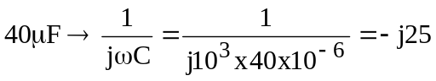

We apply nodal analysis to the circuit below.

V_{o} 20I_{x}
+ –
I_{x}

j20
50
6∠0º

–j25 10

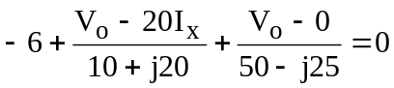
But 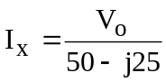. Substituting this and solving for V_{o} leads

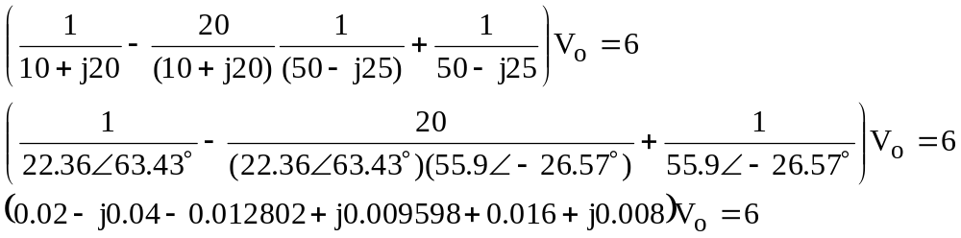
(0.0232 – j0.0224)V_{o} = 6 or V_{o} = 6/(0.03225∠–43.99˚) = 186.05∠43.99˚ volts.

|I_{x}| = 186.05/55.9 = 3.328

We can now calculate the average power absorbed by the 50-Ω resistor.

P_{avg} = [(3.328)²/2]x50 = 276.8 W.

